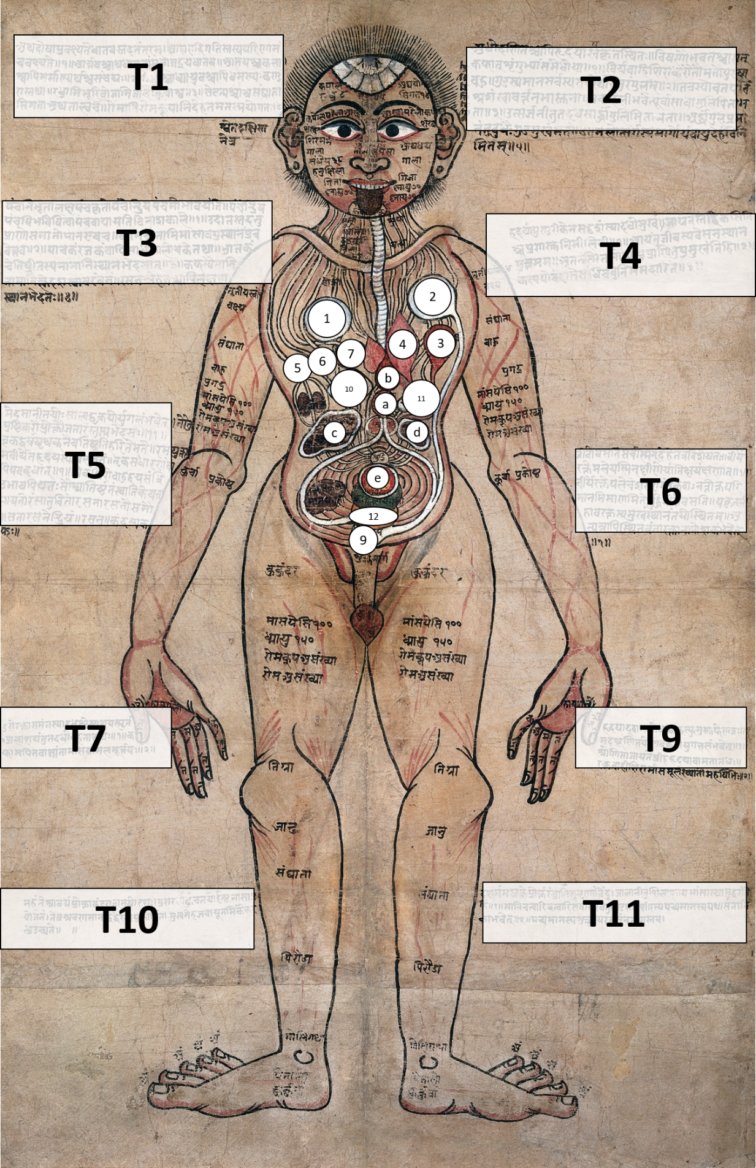

रस स्थान

Rasa sthāna

Chyle gland

शुक्र स्थान

Śukra sthāna

Semen gland

1. रक्ताशय

Rakta aśaya

Blood gland

फोक्सो

phuphphusa

Lung

* The manuscript contains the Nepali term फोक्सो (फुफ्फुस)

पित्त

Pitta

Bile

वात

Vāta

Air

कफ

Kapha

Phlegm

मूत्राशय

Mūtra sthāna

Urinary station

इन्द्रिय स्थान

Indriya sthāna

Sensory station

ओज स्थान

Oja sthāna

Vigour station

मल स्थान

Mala sthāna

Excretory station

*Unclear text/based on textual support from Suśrutasaṃhitā

**a.**

पक्वाशय

Pakvāshaya

Digested food organ

**b.**

आमाशय

Āmāshaya

Improperly digested food organ

**c.**

यकृत्

Yakr̥t

Liver

**d.**

प्लीहन्

Plīha

Spleen

**e.**

अग्नि

Agni

Fire

**T1**

अथ दोषा प्रवक्ष्यंते धातवस्तदनंतरम् आहारादि गतिस्तस्य परिणामं च वक्ष्यते

आरत्तवाश्चाथ घातूनां मालाजद्रयपधातव आमयश्च कला श्वापि मरमाण्यर्थश्च संचयः

श्चाधायुवश्चापि धमण्यः कण्ड रास्तथा रन्ध्रामि भूरि वोजामि जालैः कुचाश्व

सेवन्यश्चाथ संधाता सिमता अथता त्वच रोमानि रोमकूपानि देह तमतस्मयोगतः

Now the humours will be described, and after that, the tissues. The movement of food etc., and its transformation will be stated; blood too, and the impurities of the tissues and the subsidiary tissues; the receptacles and the layers of skin, the lethal points and the joints; and the ducts and sinews as well as the pipes and the tendons too; the orifices and mass of tubes with nets, and the brushes and ropes; the grooves too, and the junctions and aggregate bones, the seams, and also the skin, the hairs and pores. The body is thought to be made of these.

**T2**

Below and to the right of the heart is the location of the liver.

The testicles arise from the essence of phlegm, blood, flesh, and fat.

They are thought to be the supporting structure for the ducts that carry virility, that convey manliness. The rectum is four and a half centimetres in total.

There are three folds in it. They are like the convolutions of a conch shell. The first is called ‘forward conductor’, and is thought to be one and a half centimetres long.

Below that is the ‘expeller’, one and a half centimetres long.

Experts consider the orifice of the rectum to be half a centimetre long. This, the anus, is the passage created in the body for the expulsion of impurity.

**T3**

[The pipes] made of all five elements five times cause the one having five senses to exist amongst the five. Having caused the one having five senses to exist amongst the five, they return to the

fivefold state at the time of death.

Up-breath, then fore-breath, co-breath, down-breath, and through-breath: these are the names of the wind distinguished according to location.

Cooker, dyer, reacher, illuminator, and shiner: these are the names of the bile, distinguished according to location.

Moistener, dripper, taster, oiler, and gluer: these are the names of the phlegm, distinguished according to location.

**T4**

The heart is similar to a lotus, facing downwards. On waking up, it blooms; on sleeping, it closes up.

That is the resting place of the soul. It is the supreme location of the consciousness. And so, when it is suffused with torpor, living creatures fall asleep.

The collarbones are defined as the junctions of the chest and the shoulders.

**T5**

The two kidneys come from the essence of fat and blood. They are said to provide nourishment for the fat in the belly.

‘Avalanbana’ is the one that brings about the propping up of the heart, by its own power together with rasa, and it also holds the upper back (E/k) together.

The ‘upper back’ is the junction of the head and the two arms.

The tongue and ‘saliva (rasana)’are equivalent because they make known tastes. They are both of the nature of Soma and they are located close to each other.

‘Tongue (rasanA)’ means the sense organ of taste; ‘Saliva (rasanah,)’ means the phlegm located in the throat.

**T6**

Life dwells in the whole body, and especially in the virility, in the blood, in the waste. Being diminished in these, it is instantly destroyed.

Life dwells in the virility, in the blood, and in the waste, that are pure when the body is first made, and in the quantity according to the metabolic process described by VAgbhaTa. Not in the corrupted and aged ones, because the instructions about bloodletting might then be pointless.

And the principal location of blood is the liver and the spleen.

Located in them, it nourishes the bloods that are positioned elsewhere.

**T7**

The chest is the receptacle of blood. The receptacle for phlegm is considered to be below it. Below that is the receptacle for digestive residues, whose details Caraka described. The receptacles of phlegm, digestive residues, bile, wind, and of waste and urine.

**T9**

Below and to the left of the heart is the left lung. It is made of blood and foam.

The two kidneys are made of the essence of fat and blood.

The spleen is made of blood. It is below and to the left of the heart.

The wise call it the root of the ducts that carry blood.

**T10**

The large sinews are called tendons and there are sixteen of them.

Their purpose is observed to be extension and contraction.

Each of the eyes, ears and nose has two obvious orifices. The mouth, urinary organ and rectum is each said to have one orifice.

**T11**

The tenth is said to be in the head. These are the orifices that men are said to have, according to the wise. The webs support the ducts, sinews, muscles, and bones. There are four fours, sixteen in all.

A layer forms on the surface of milk when it is being cooked. In just the same way, the skin is formed out of semen and menstrual blood as they mature.

**Credits**

The Ayurvedic Man, c.18th century. Credit: [Wellcome Collection](https://wellcomecollection.org/works/s7aj78r2). [CC BY](https://creativecommons.org/licenses/by/4.0/)

**Reference**

Suśrutasaṃhitā (śarīrasthāna 5.8)

सुश्रुत संहिता 3.5.7-8

*Sanskrit*

आशायास्तु वाताशयः पित्ताशयः श्लेष्माशयो रक्ताशय आमाशयः पक्वाशयो मूत्राशयः स्त्रीणां गर्भाशयोऽष्टम इति

*Translation*

They are named as the Vatashaya (the receptacle of the bodily Vayu), Pittashaya (the receptacle of the Pitta), Sleshmashaya (the receptacle of Sleshma or Kapha), Raktashaya (the receptacle of the blood), Amashaya (stomach), Pakvashaya (intestines), and the Mutrashaya (bladder). Females have another ashaya (receptacle) in addition to these which is called the Garbhashaya (uterus).